# MOVIE REVIEW WEBSITE

HOME PAGE

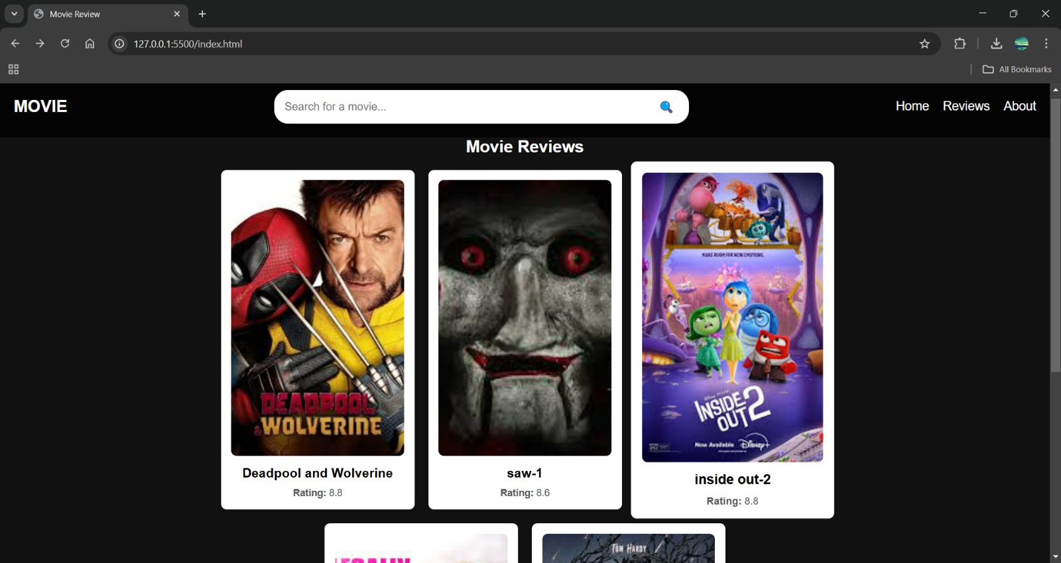

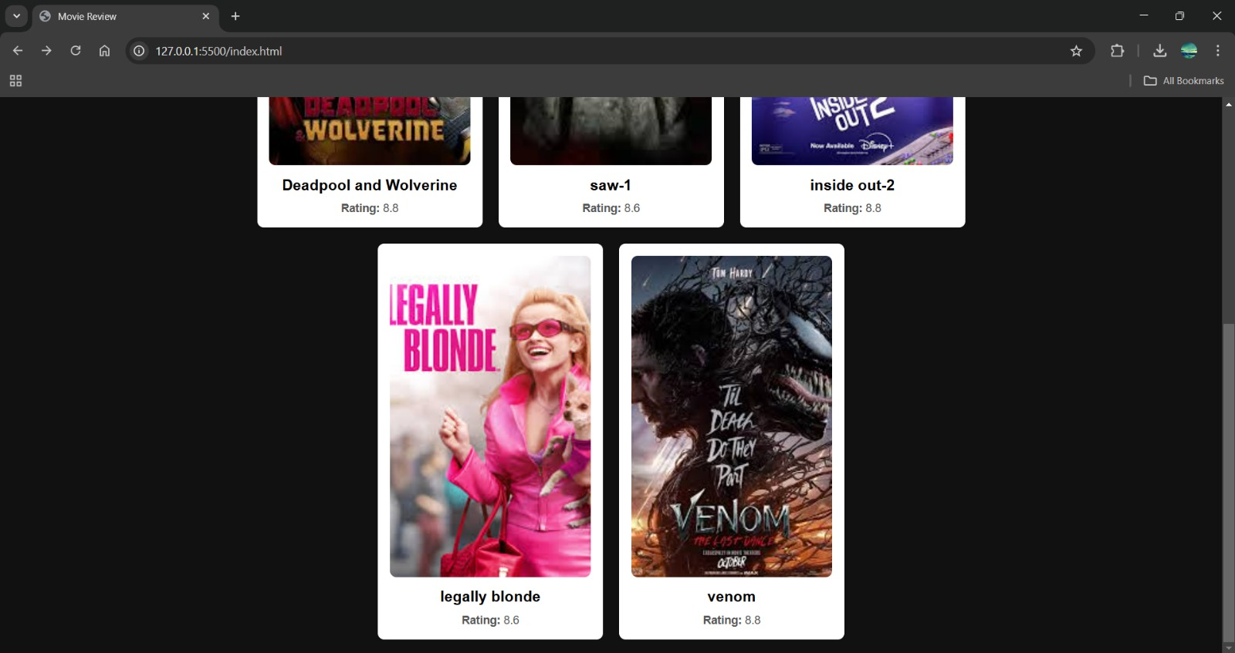

## SEARCH BAR

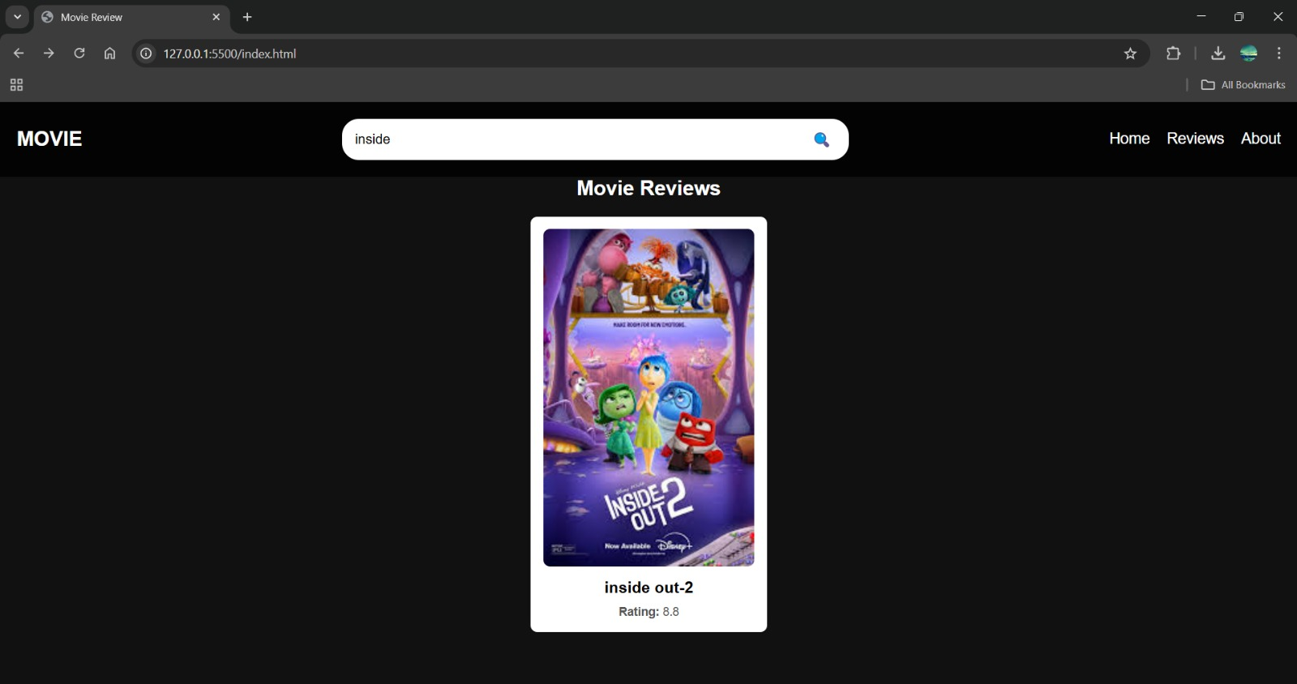

## ABOUT THE WEBSITE

## ABOUT.jpg

## SUBMIT THE REVIEWS

